**Swiggy Delivery Analytics Report- GUVI Capstone Project**

**Prepared By Ramkishore Prabakaran**

**Task 1: Top 10 Areas with Most Restaurants**

Page 1: The top 10 Areas with the Most Restaurants were analyzed with the help of a Bar Chart(in y-axis Area and X-axis count of restaurants), Overall Rohini from Delhi has more Restaurants.

**Task 2: Most Popular Food Types Served by Swiggy Restaurants in Each City**

Page 1: I have included 2 slicers so we can change the city's food type and we can analyze the most popular food types in each city with the help of Bar chat( in y-axis Food Type and X-axis count of the city ) overall most popular food type is Indian.

**Task 3: Top Rated Swiggy Restaurants (In Percentage)**

The data is represented in the pie chart, and the data is filtered with criteria average rating above 4.5 and percentage calculated. **51.23%** of restaurants rated 4.6 and **5.56 %** were rated 5

**Task 4: Correlation of Factors Affecting Average Rating**

I used a key influencer chart to analyze the Average Rating explained by area, city, food type, and restaurant where a key influencer found an area especially the area called **Matunga Wadala** influenced **69%** with a rating. This clearly explains a clear problem with 20 restaurants with an average rating of **2.97** and a minimum delivery time of 45 minutes.

**Task 5: Correlation Between Restaurant Price and Average Rating**

A scatterplot was used to analyze the Correlation between Price and average rating. As a result, I observed prices between 200-400 the rating ranges from 1-3 along with outliers there is no prominent correlation observed which can be a game-changer rating based on the quality of food, food packing, quality, quantity taste, and customer satisfaction.

**Task 6: City-wise Restaurant Count**

City Restaurant count was represented in the bar graph, alternatively, we can modify the slider and find the count too

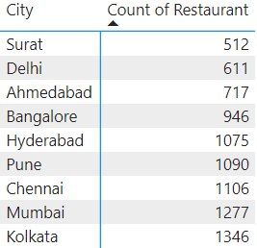

**Task 7: Price Analysis**

Price data is represented in gauge. The average price per order is Rs.348.44 by adjusting the slider we can analyze data based on city and food type.

**Task 8: Delivery Time Analysis**

The delivery time is analysed using a Gauge that explains the minimum, maximum, and average time for delivery. The minimum Delivery time is 20mins and maximum delivery time is 109 mins and the average is 53 mins

**Task 9: Cuisine Analysis**

**By adjusting the Food type slicer we can analyse this data based on the cuisine type**

**Task10: Area-wise Restaurant Analysis**

**I included a slicer for the area, and city by the way we can analyze data based on any particular area in a city**

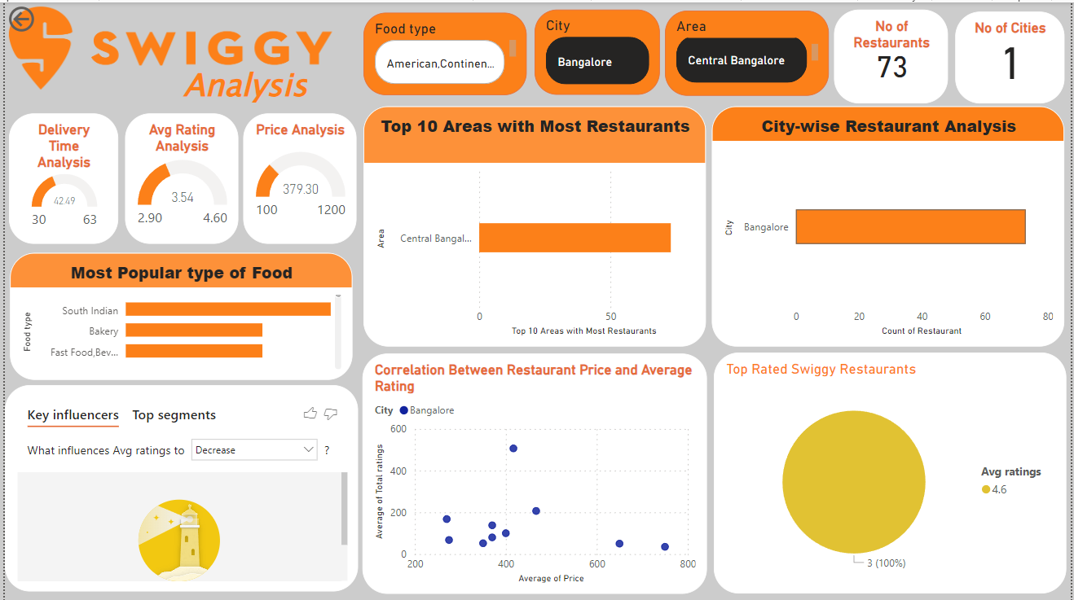

**Example Data sorted by City: Bangalore and Area Central Bangalore- 73 restaurants found with 3.5 Average rating and 42 mins as average delivery time with 379.30 average delivery cost and 3 restaurants have been in top rated 4.6 rating**

**Task 11: Correlation Analysis**

Page 2: There is a Prominent correlation observed with delivery time by reducing the delivery time we can increase the rating as per the key influencer average rating increases by 48% if decrease the delivery time to less than 31 mins.

**Task 12: Customer Feedback Analysis**

Customer feedback is average to good most of the total ratings distributed between 3.5 to 4 ratings. This can be analyzed in Line graph distribution between distinct counts of total rating and an average rating

**Task 13: Geographical Mapping**

The map was plotted using ArcGIS PowerBi map using Area as the location.

**Task 14: Business Recommendations**

My analysis highlights a critical issue in the Quick Commerce industry, where delivery time is a significant factor in customer satisfaction. The average delivery time of 53.97 minutes, which is close to an hour, presents a considerable challenge, especially in a market where speed is crucial.

**Key Points from the Analysis:**

1. **Average Delivery Time:** With an average delivery time of nearly 54 minutes, the current performance is problematic. In the Quick Commerce industry, where speed is a primary selling point, such delays could lead to customer dissatisfaction.
2. **Bad Rating Location:** The Matunga-Wadala area is significantly impacted by poor ratings, with 20 restaurants in this zone averaging a low rating of 2.97. This reflects negatively on customer satisfaction in the region.
3. **Competition:** Swiggy faces competition not only from Zomato but also from Quick Commerce platforms like Zepto and even its own product, Instamart. These platforms offer instant food products, which may become more appealing to customers if restaurant deliveries continue to take too long.
4. **Customer Behaviour:** If customers perceive that ordering food from restaurants takes too long, they might shift their focus to quicker alternatives like ready-to-eat meals or grocery delivery services that offer faster turnaround times.

**Potential Recommendations:**

1. **Optimize Delivery Logistics:** To remain competitive, Swiggy should optimize its delivery processes. This could involve improving route planning, enhancing communication between restaurants and delivery personnel, or offering incentives for faster service.
2. **Set Expectations:** Communicating expected delivery times to customers and providing real-time updates can help manage expectations and reduce dissatisfaction.
3. **Explore Partnerships:** Collaborating with restaurants to streamline preparation times or offering quicker options on the menu could help reduce overall delivery times.
4. **Identify and Address Low-Rating Locations:** Regularly identifying areas like Matunga-Wadala with consistently low ratings is crucial. By pinpointing these problem locations, Swiggy can take targeted actions to address the issues.
5. **Improve Service Quality:** Enhancing the quality of service in these low-performing areas could involve optimizing delivery times, improving communication between restaurants and delivery personnel, and possibly reassessing the restaurant partnerships in these regions.
6. **Enhance Market Potential:** By rectifying the issues in problematic locations and delivering better service, Swiggy has the opportunity to improve its market potential, increase sales, and bolster its goodwill among customers.

My analysis underscores the importance of speed in the Quick Commerce industry. Improving delivery times could significantly enhance customer satisfaction and strengthen Swiggy’s competitive positioning.